[**04 - Iteration Control Structures**](https://www.rajalakshmicolleges.net/moodle/course/view.php?id=84#section-4)

**Ex. No:4.1 Date: 13.04.24**

**Register No.: 2116231801109 Name: Mohan Raji P**

**Nth Fibonacci**

Write a [program](https://www.rajalakshmicolleges.net/moodle/mod/quiz/view.php?id=3478) to return the nth number in the fibonacci series. The value of N will be passed to the [program](https://www.rajalakshmicolleges.net/moodle/mod/quiz/view.php?id=3478) as input.

NOTE: Fibonacci series looks like –

0, 1, 1, 2, 3, 5, 8, 13, 21, 34, 55, . . . and so on.

i.e. Fibonacci series starts with 0 and 1, and continues generating the next number as the sum of the previous two numbers.

• first Fibonacci number is 0,

• second Fibonacci number is 1,

• third Fibonacci number is 1,

• fourth Fibonacci number is 2,

• fifth Fibonacci number is 3,

• sixth Fibonacci number is 5,

• seventh Fibonacci number is 8, and so on.

**For example:**

| **Input** | **Result** |
| --- | --- |
| 1  4  7 | 0  2  8 |

**Program:**

a=int(input())

b=0

c=1

if(a==1):

print("0")

elif(a==2):

print("1")

else:

for i in range (3,a+1):

d=b+c

b=c

c=d

print(d)

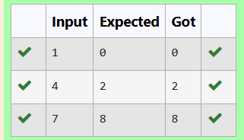

**Ex. No: 4.2 Date: 13.04.24**

**Register No.: 2116231801105 Name: Mohammed Faisal S.M.**

[**Factors of a number**](https://www.rajalakshmicolleges.net/moodle/mod/quiz/view.php?id=5720)

Determine the factors of a number (i.e., all positive integer values that evenly divide into a number).

**For example:**

| **Input** | **Result** |  |
| --- | --- | --- |
| 20 | 1 2 4 5 10 20 |  |

**Program:**

a=int(input())

for i in range(1,a+1):

if(a%i==0):

print(i,end=" ")

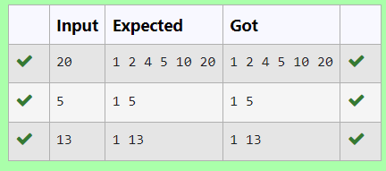

**Ex. No: 4.3 Date: 13.04.24**

**Register No.: 2116231801105 Name: Mohammed Faisal S.M.**

**Product of single digit**

Given a positive integer N, check whether it can be represented as a product of single digit numbers.

Input Format:

Single Integer input.

Output Format:

Output displays Yes if condition satisfies else prints No.

Example Input:

14

Output:

Yes

Example Input:

13

Output:

No

**Program:**

a=int(input())

c=0

for i in range(1,10): for j in range(1,10):

if i*j==a:

c=1

if(c==1):

print("Yes")

▾else:

print("No")

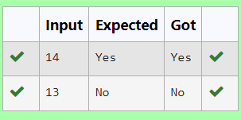

**Ex. No: 4.4 Date: 13.04.24**

**Register No.: 2116231801105 Name: Mohammed Faisal S.M.**

**Unique Digit Count**

Write a program to find the count of unique digits in a given number N. The number will be passed to the program as an input of type int.

Assumption: The input number will be a positive integer number >= 1 and <= 25000.

For e.g.

If the given number is 292, the program should return 2 because there are only 2 unique digits '2' and '9' in this number

If the given number is 1015, the program should return 3 because there are 3 unique digits in this number, '1', '0', and '5'.

**For example:**

| **Input** | **Result** |
| --- | --- |
| 292 | 2 |
| 1015 | 3 |

**Program:**

a=input()

b=len(set(a))

print(b)

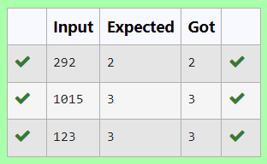

**Ex. No: 4.5 Date: 13.04.24**

**Register No.: 2116231801105 Name: Mohammed Faisal S.M.**

[**Non**](https://www.rajalakshmicolleges.net/moodle/mod/quiz/view.php?id=5717) **Repeated Digit Count**

Write a program to find the count of non-repeated digits in a given number N. The number will be passed to the program as an input of type int.

Assumption: The input number will be a positive integer number >= 1 and <= 25000.

Some examples are as below.

If the given number is 292, the program should return 1 because there is only 1 non-repeated digit '9' in this number

If the given number is 1015, the program should return 2 because there are 2 non-repeated digits in this number, '0', and '5'.

If the given number is 108, the program should return 3 because there are 3 non-repeated digits in this number, '1', '0', and '8'.

If the given number is 22, the function should return 0 because there are NO non-repeated digits in this number.

| **Input** | **Result** |
| --- | --- |
| 292 | 1 |
| 1015 | 2 |
| 108 | 3 |
| 22 | 0 |

**For example:**

**Program:**

a={}

for i in input:

if i in a:a[i]+=1

else:a[i]=1

print(sum([1 for i in a if a[i]==1]))

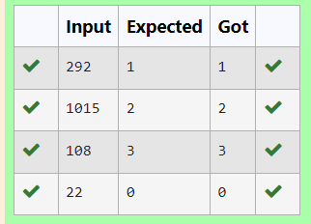

**Ex. No: 4.6 Date: 13.04.24**

**Register No.: 2116231801105 Name: Mohammed Faisal S.M.**

**Next Perfect Square**

Given a number N, find the next perfect square greater than N.

Input Format:

Integer input from stdin.

Output Format:

Perfect square greater than N.

Example Input:

10

Output:

16

**Program:**

import math

a=int(input())

b = a + 1

while b > 0 :

m=math.sqrt(b)

if(m==int(m)):

print(b)

break

else:

b = b + 1

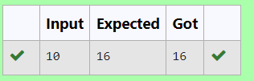

**Ex. No: 4.7 Date: 13.04.24**

**Register No.: 2116231801105 Name: Mohammed Faisal S.M.**

**Sum of Series**

Write a program to find the sum of the series 1 +11 + 111 + 1111 + . . . + n terms (n will be given as input from the user and sum will be the output)

Sample Test Cases

Test Case 1

Input

4

Output

1234

Explanation:

as input is 4, have to take 4 terms.

1 + 11 + 111 + 1111

Test Case 2

Input

6

Output

123456

**For example:**

| **Input** | **Result** |
| --- | --- |
| 3 | 123 |

**Program:**

a=int(input())

t=1

s=0

for i in range(a)

s+=t

t=t*10+1

print(s)

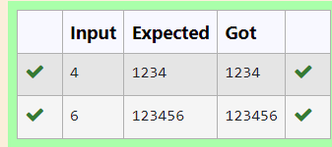

**Ex. No: 4.8 Date: 13.04.24**

**Register No.: 2116231801105 Name: Mohammed Faisal S.M.**

**Prime Checking**

Write a program that finds whether the given number N is Prime or not. If the number is prime, the program should return 2 else it must return 1.

Assumption: 2 <= N <=5000, where N is the given number.

Example1: if the given number N is 7, the method must return 2

Example2: if the given number N is 10, the method must return 1

**For example:**

| **Input** | **Result** |
| --- | --- |
| 7 | 2 |
| 10 | 1 |

**Program:**

a=int(input())

c=0

for i in range(2,a):

if(a%i==0):

c=1

if(c==1):

print("1")

elif(c==0): print("2”)

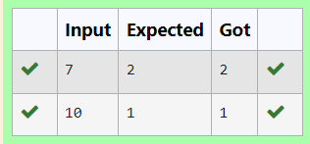

**Ex. No: 4.9 Date: 13.04.24**

**Register : 2116231801105 Name: Mohammed Faisal S.M.**

**Disarium Number**

A Number is said to be Disarium number when the sum of its digit raised to the power of their respective positions becomes equal to the number itself. Write a [program](https://www.rajalakshmicolleges.net/moodle/mod/quiz/view.php?id=3478) to print number is Disarium or not.

Input Format:

Single Integer Input from stdin.

Output Format:

Yes or No.

Example Input:

175

Output:

Yes

Explanation

1^1 + 7^2 +5^3 = 175

Example Input:

123

Output:

No

**For example:**

| **Input** | **Result** |
| --- | --- |
| 175 | Yes |
| 123 | No |

**Program:**

a=input()

n=len(a)

r=0

for i,d in enumerate(a):

r+=int(d)**(i+1)

if r==int(a):

print("Yes")

else:

print("No")

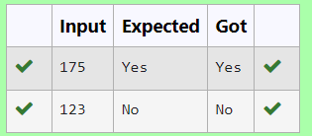

**Ex. No: 4.10 Date: 13.04.24**

**Register No.: 2116231801105 Name: Mohammed Faisal S.M.**

**Perfect Square After adding One**

Given an integer N, check whether N the given number can be made a perfect square after adding 1 to it.

Input Format:

Single integer input.

Output Format:

Yes or No.

Example Input:

24

Output:

Yes

Example Input:

26

Output:

No

**For example:**

| **Input** | **Result** |
| --- | --- |
| 24 | Yes |

**Program:**

import math

a=int(input())

b=a+1

c=math.sqrt(b)

if(c==int(c)):

print("Yes")

else:

print("No")

